Ocean Currents Worksheet Homework Assignment

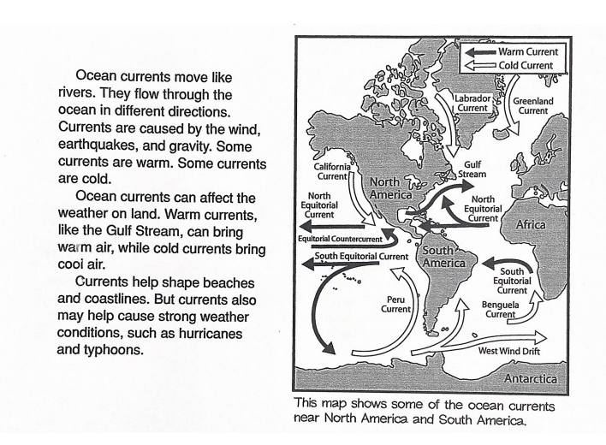

1. How do you think the North Equatorial and South Equatorial currents got their names? I think the North and the South equatorial current got their names because the North Equatorial current flows up and North is up and the South Equatorial current flows down because south is down.
2. What warm current flows along the east coast of the United States? The South Equatorial.
3. How do warm currents affect the weather? Warm currents affect the weather by causing strong weather conditions such as hurricanes and typhoons.
4. What causes ocean currents? Ocean currents are caused by wind, earthquakes, and gravity.
5. What currents do you think affect the United States' weather the most? Why? I think the cold currents affect the United States the most because for most of the year I feel cold currents pass by a lot and warm currents only pass really in the summer.
6. What happens at the end of most cold currents? At the end of most cold currents they go off in different directions and flow in different places.